**LOAD CASES - MECAMASTER**

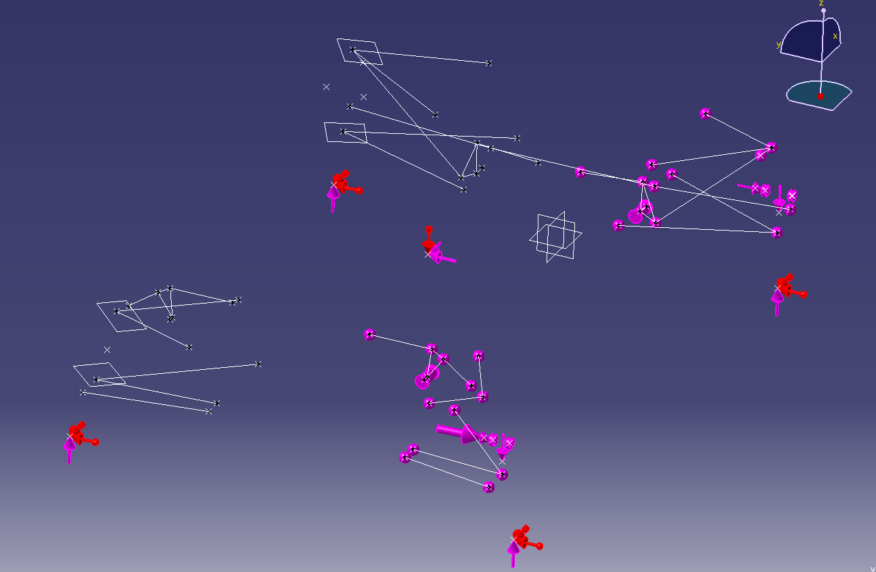

Figure 1: General view of MecaMaster model

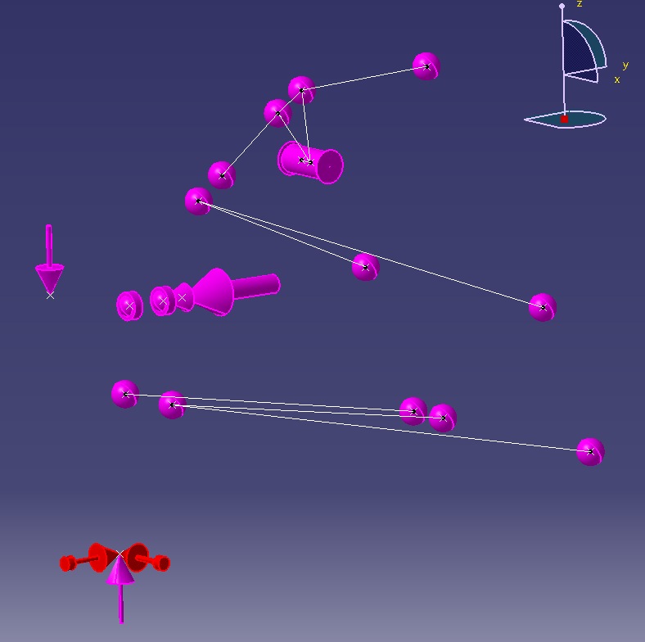

Figure 2: Rear right wheel detail

|  |  |
| --- | --- |
| **LOAD CASE** | **Hypothesis for removing the hyperstatism** |
| Left Turn 2G | Longitudinal plan of symmetry |
| Right Turn 2G | Longitudinal plan of symmetry |
| Left Turn 1G + Braking 1G | Rear internal wheel > Fz=0N |
| Right Turn 1G + Braking 1G | Rear internal wheel > Fz=0N |
| Acceleration 0.77G | Lateral plan of symmetry |
| Braking 2G | Lateral plan of symmetry |
| Inverse Braking 0.5G | Lateral plan of symmetry |
| Bump 3G | Lateral plan of symmetry |

## Hypothesis

|  |  |
| --- | --- |
| **LOAD CASE** | **HYPOTHESIS TO REMOVE THE HYPERSTATISM** |
| Left Turn 2G | Longitudinal plan of symmetry |
| Right Turn 2G | Longitudinal plan of symmetry |
| Left Turn 1G + Braking 1G | Rear internal wheel > Fz=0N |
| Right Turn 1G + Braking 1G | Rear internal wheel > Fz=0N |
| Acceleration 0.77G | Lateral plan of symmetry |
| Braking 2G | Lateral plan of symmetry |
| Inverse Braking 0.5G | Lateral plan of symmetry |
| Bump 3G | Lateral plan of symmetry |

## Examples of results

|  |  |  |  |  |  |  |
| --- | --- | --- | --- | --- | --- | --- |
| **Part** | **Acceleration 0.77g**  **(N)** | **Braking 2g**  **(N)** | **Left turn 1g + braking 1g (N)** | **Left turn 2g**  **(N)** | **Reverse braking 0.5g**  **(N)** | **Bump 3g**  **(N)** |
| Steering link | 12 | 73 | 411 | 860 | 26 | 50 |
| Toe link | 1286 | 30 | 520 | 1402 | 207 | 345 |
| Front pullrod | 1104 | 2723 | 2542 | 2730 | 1265 | 4669 |
| Rear pushrod | 1148 | 222 | 1020 | 1472 | 1056 | 2669 |
| Front lower A-Arm, front pivot | 53 | 5827 | 1973 | 2090 | 600 | 224 |
| Rear lower A-Arm, front pivot | 1534 | 1169 | 3928 | 3190 | 1623 | 475 |

## 